FEC Database Owner’s Manual

Main toolbar

1. 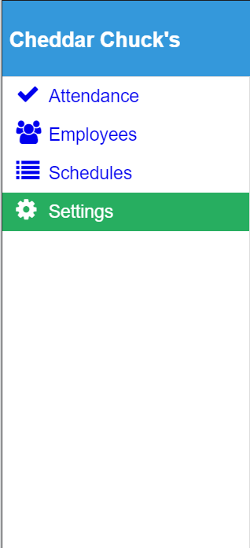Edit Attendance and print reports.
2. Edit and manage list of employees.
3. Create, edit and print schedules.
4. Modify settings

Attendance

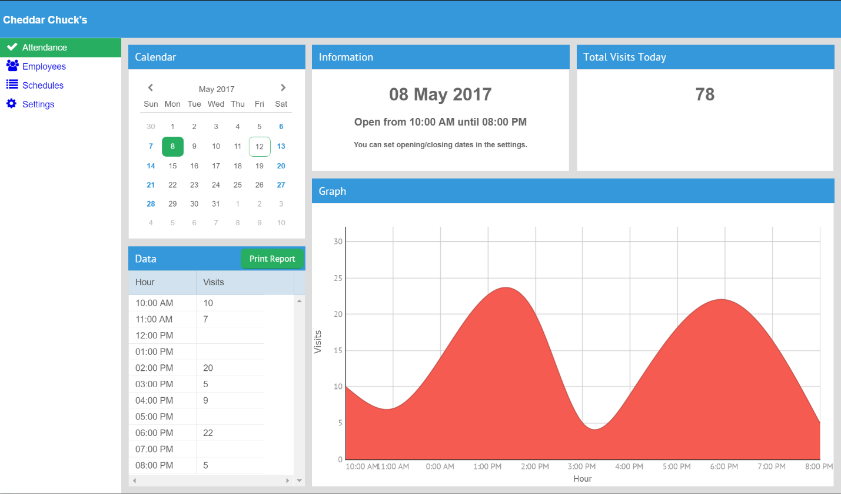

1. Select the date to edit. The current date is outlined.
2. Edit visits per hour. Click on a cell to edit its value. Changes will be saved automatically.
3. Total visits.
4. Visits over time.

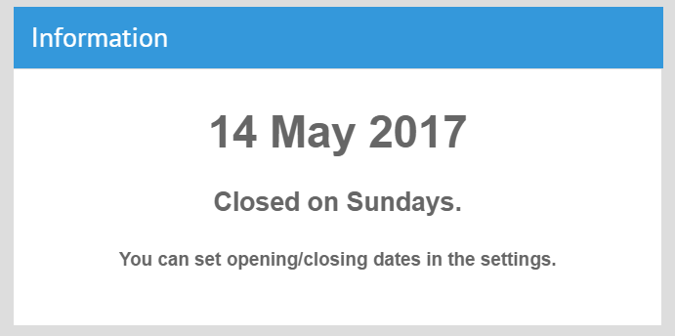If you see this screen, make sure you have the correct opening hours set in the settings, or select a day when the business is open.

Employees

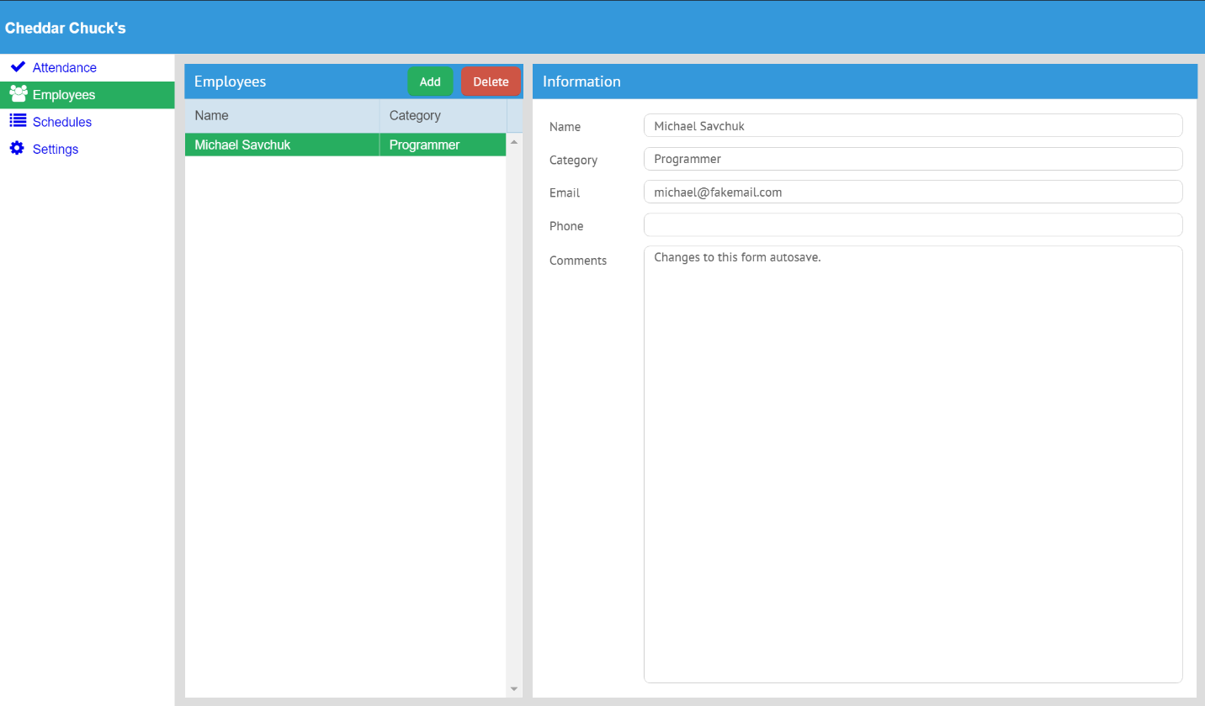

1. View list of employees. Click on “Name” in the header bar to toggle the sorting from A-Z to Z-A.
2. Add a new employee or remove the currently selected one using the toolbar buttons.
3. View and edit data associated with an employee. Changes will be saved automatically.

Schedules

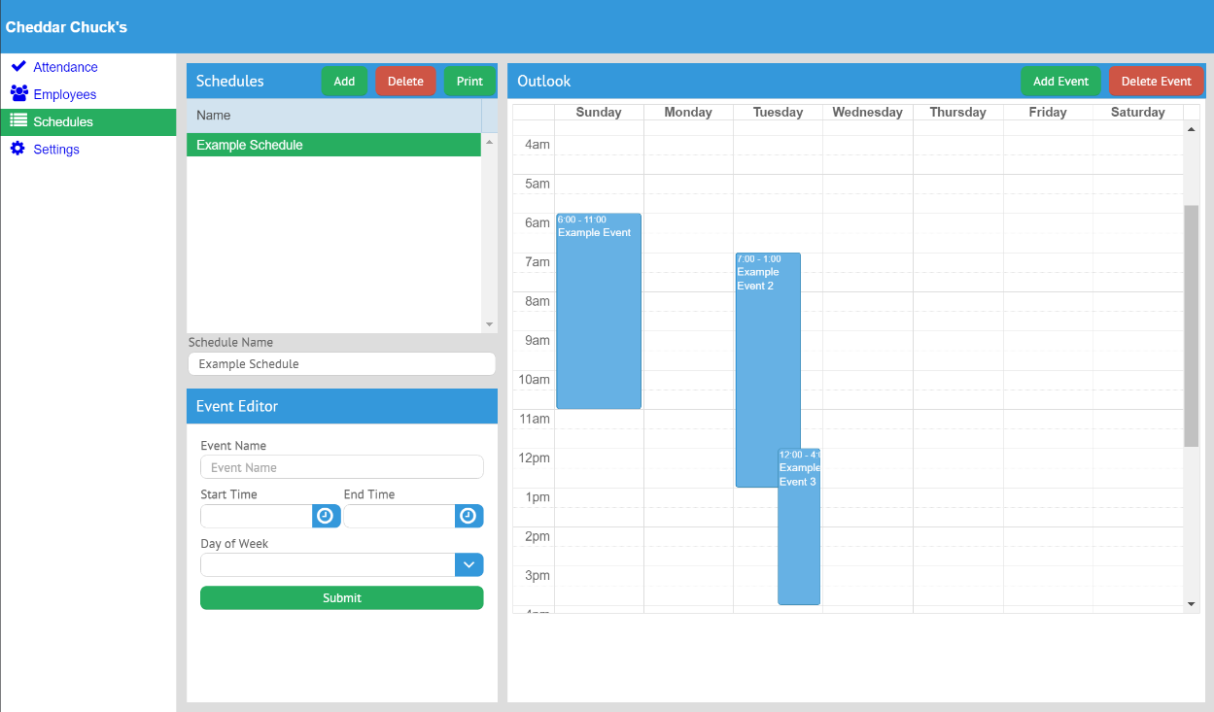

1. View list of schedules.
2. Add a new schedule, delete the currently selected one, or print it.
3. Edit the schedule name.
4. Rearrange and resize events in the schedule.
5. Add a new event or delete the currently selected one. (Select an event by clicking on it)
6. 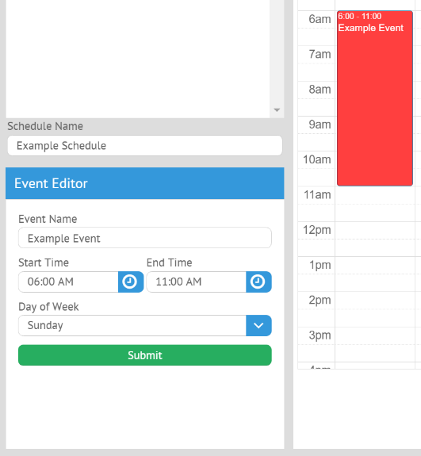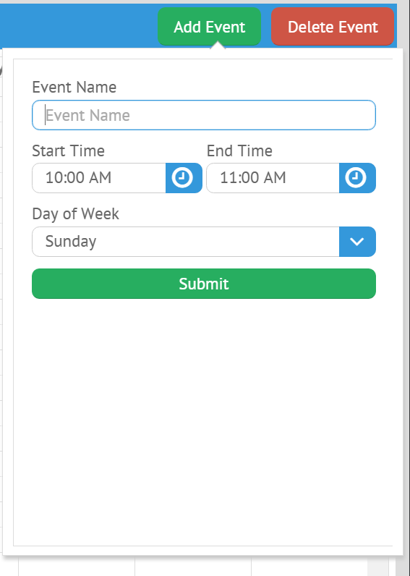Edit the currently selected event

Clicking “Add Event” will allow you to fill out basic information about the event before clicking “Submit” to create it

Click an event to select it. Then, you may edit the individual properties via the “Event Editor” panel. Click submit to submit the changes from the editor to the event.

Settings

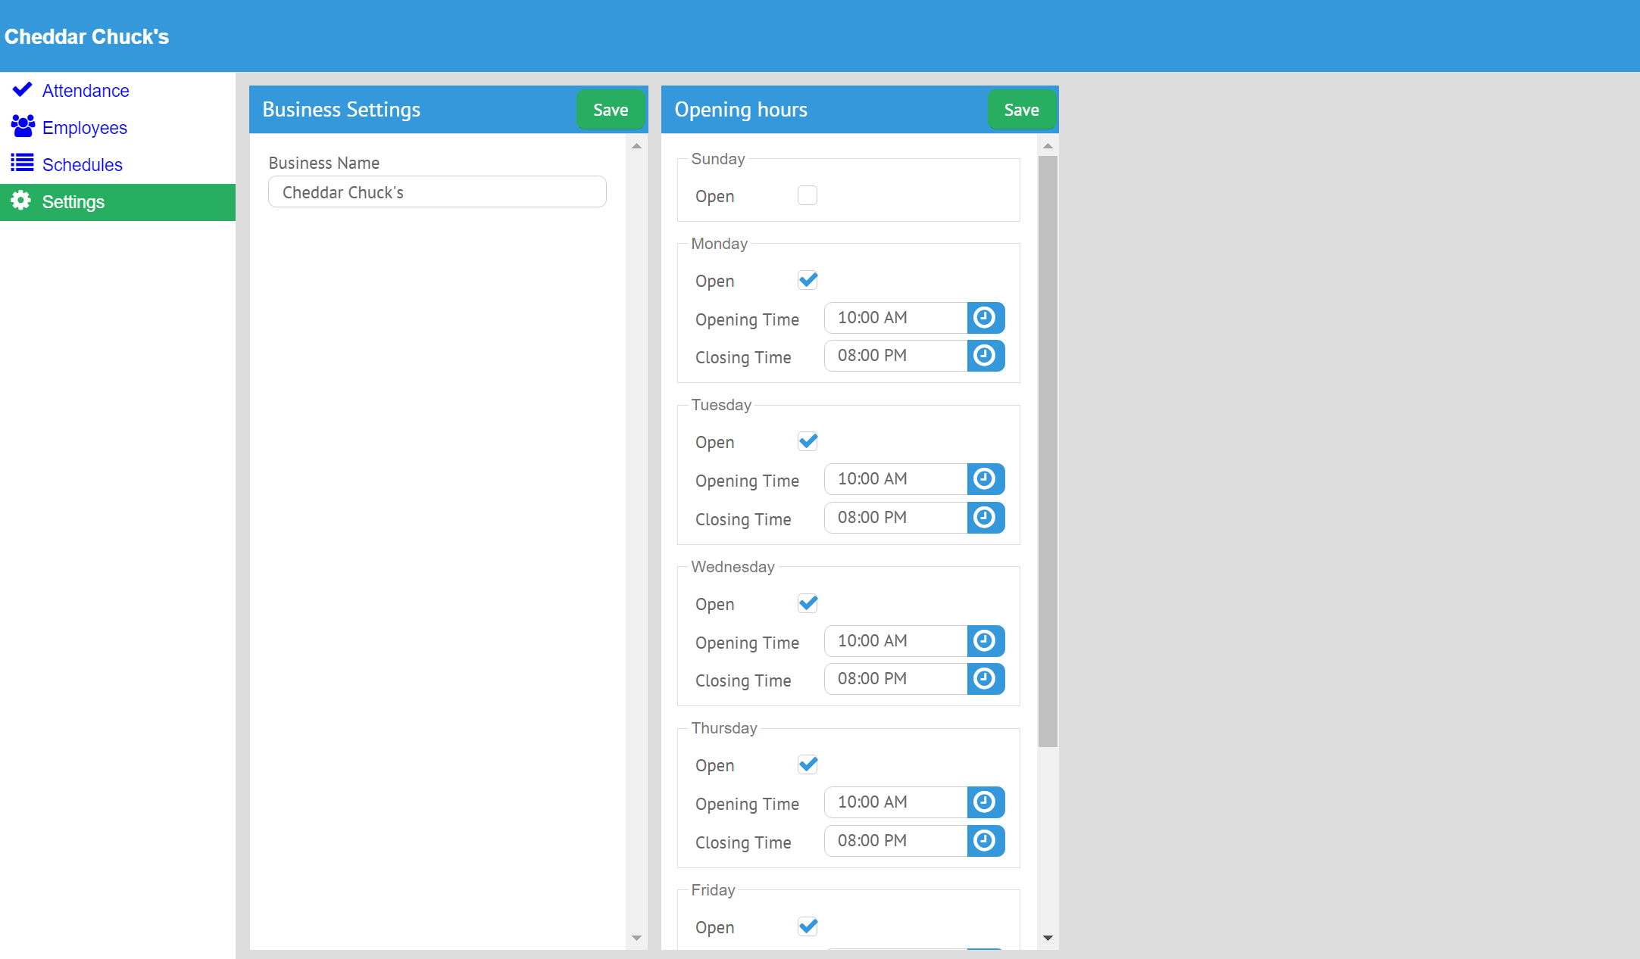

1. Edit thee business name. Click “Save” on the toolbar to save changes.
2. Edit opening hours. If the business is open during a day, check the “Open” checkbox, then fill out the specific opening/closing time information. These settings are used for attendance reports.